Name: Jatvish Yechuri
Reg no: 220905246
Roll no: 36
CSE – C
Title: CD Lab – 5(week 6)
Date: 5/2/2025

1. Count the number of vowels and consonants in the given input.

Code:

%{
#include <stdio.h>
int vowels = 0, consonants = 0;
%}

%%

[aAeEiIoOuU] { vowels++; }
[a-zA-Z] { consonants++; }

%%

int main() {
printf("Enter string: ");
yylex();
printf("Vowels: %d, Consonants: %d\n", vowels, consonants);
return 0;
}

int yywrap() {
return 1;
}

Screenshot:

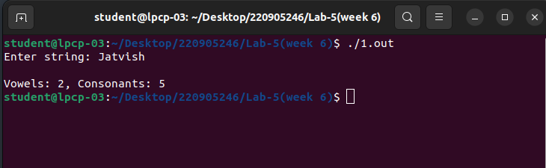

2. Count the number of words, characters, blanks and lines in a given text.

Code:

%{
#include <stdio.h>
int words = 0, chars = 0, blanks = 0, lines = 0;
%}

%%

[a-zA-Z]+ { words++; chars += yyleng; }
[ \t] { blanks++; chars++; }
\n { lines++; chars++; }

%%

int main() {
printf("Enter string: ");
yylex();
printf("Words: %d, Characters: %d, Blanks: %d, Lines: %d\n", words, chars, blanks, lines);
return 0;
}

int yywrap() {
return 1;
}

Screenshot:

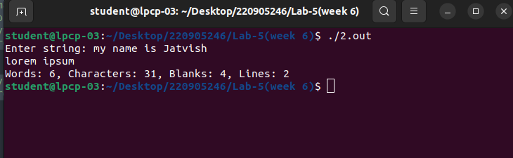

3. Find the number of positive integer, negative integer, positive floating positive number and negative floating point number

Code:

%{
#include <stdio.h>
int int_count = 0, float_count = 0;
%}

%%

[0-9]+ { int_count++; }
[0-9]+\.[0-9]+ { float_count++; }

%%

int main() {
printf("Enter string of different types of numbers: ");
yylex();
printf("Integers: %d, Floating Points: %d\n", int_count, float_count);
return 0;
}

int yywrap() {
return 1;
}

Screenshot:

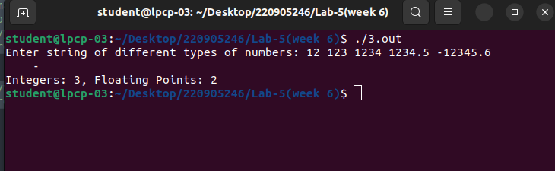

4. Given a input C file, replace all scanf with READ and printf with WRITE statements also find the number of scanf and printf in the file.

Code:

%{
#include <stdio.h>
%}

%%

scanf { printf("READ "); }
printf { printf("WRITE "); }
. { putchar(yytext[0]); }

%%

int main() {
yylex();
return 0;
}

int yywrap() {
return 1;
}

Screenshot:

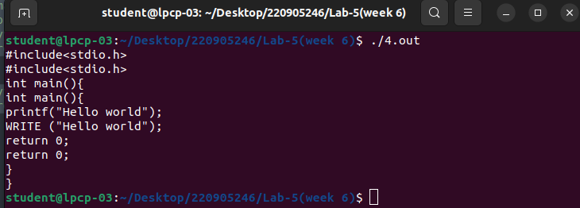

5. That changes a number from decimal to hexadecimal notation.

Code:

%{
#include <stdio.h>
#include <stdlib.h>
%}

%%

[0-9]+ {
int num = atoi(yytext);
printf("Hexadecimal: %X\n", num);
}

%%

int main() {
printf("Enter a decimal number: ");
yylex();
return 0;
}

int yywrap() {
return 1;
}

Screenshot:

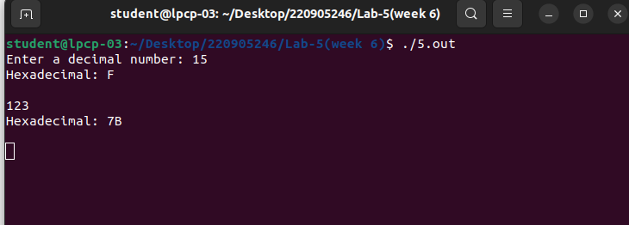

6. Convert uppercase characters to lowercase characters of C file excluding the characters present in the
comment.

Code:

%{
#include <stdio.h>
%}

COMMENT1 "//".*
COMMENT2 "/*"([^*]|[\r\n]|"*"([^/]|[\r\n]))*"*/"

%%

{COMMENT1} { printf("%s", yytext); } // Print single-line comments as is
{COMMENT2} { printf("%s", yytext); } // Print multi-line comments as is
[A-Z] { printf("%c", yytext[0] + 32); } // Convert uppercase to lowercase
. { printf("%s", yytext); } // Print all other characters unchanged

%%

int main() {
printf("Enter C code (Ctrl+D to end input on Linux, Ctrl+Z on Windows):\n");
yylex();
return 0;
}

int yywrap() {
return 1;
}

Screenshot:

